**DATA SCIENTISTS JOBS DATA ANALSYIS**

Contents

Introduction: 1

Results & Discussion: 1

Conclusion: 6

# List of Figures

Figure 1: Job postings by state 2

Figure 2: Overall distribution of salaries 3

Figure 3: Salary statistics by state 3

Figure 4: Average salary by state 4

Figure 5: Top 5 in demand jobs 4

Figure 6: Top 5 in demand industries 5

Figure 7: Average salaries by industry 5

Figure 8: Number of job postings by date 6

Figure 9: Relationship between week day and jobs posted 6

# Introduction:

The main goal of this project is to learn from and understand the data scientist job posts on seek.com.au. We will "scrape" the website to get job data, and our main goals will be to get the important information, clean up the data, and do a thorough analysis. First, we will look at how many positions are open in each state. By looking at how job openings are spread across states, we hope to find out if the demand for data scientists is different in different areas. This analysis will help you figure out where most of the job chances in the field are. The next step will be to look at facts about salaries. Our research will look at both how salaries are spread out overall and how they vary by state. We hope to find trends or correlations by looking at the links between states, the number of jobs, and salaries. This will help us figure out if some states have higher wages or more high-paying data scientist jobs than others. Next, we'll look at how popular different job names are in the field of data science. By looking at how often job names are used, we can find the most-wanted jobs and learn more about how data science roles are changing. Using the top-level classifications, we will also look into how data science job postings are spread across different businesses. This analysis will show which industries are looking for data scientists and how salaries vary from one area to the next. We will also look at how job ads are related to time. By looking at how many jobs are posted over time, we can see if there are any trends or changes in the demand for data scientists. We will also look at how the number of jobs posted changes depending on what day of the week it is. This study will show if there are certain days of the week that are better for posting jobs or if there are patterns to when jobs are posted. We will use numerical and graphical reports throughout this project to answer the questions above. By combining statistical measures, data visualizations, and methods for exploring data, we hope to give a full picture of the data scientist job market in Australia by pointing out key trends, patterns, and relationships. Overall, this study will help people understand the data science job market better, help job seekers make smart choices, and give employers and policymakers in the field of data science important information.

# Results & Discussion:

When we looked at the amount of data scientist job openings in each state, we found that New South Wales (NSW) had the most, with 175 positions, followed by Victoria (VIC), with 162 positions. Queensland (QLD) with 59 positions being posted, while the Australian Capital Territory (ACT) has 35 positions being posted and Western Australia (WA) has 27 positions posted. South Australia (SA) had 22 positions, while Tasmania (TAS) and Northern Territory (NT) each had 6 and 5 positions posted. Other areas with fewer jobs included St, Far, Bay, and CBD. These results are in line with our original goal of studying how jobs are spread across states, and they show that most data scientist jobs are in NSW and VIC.

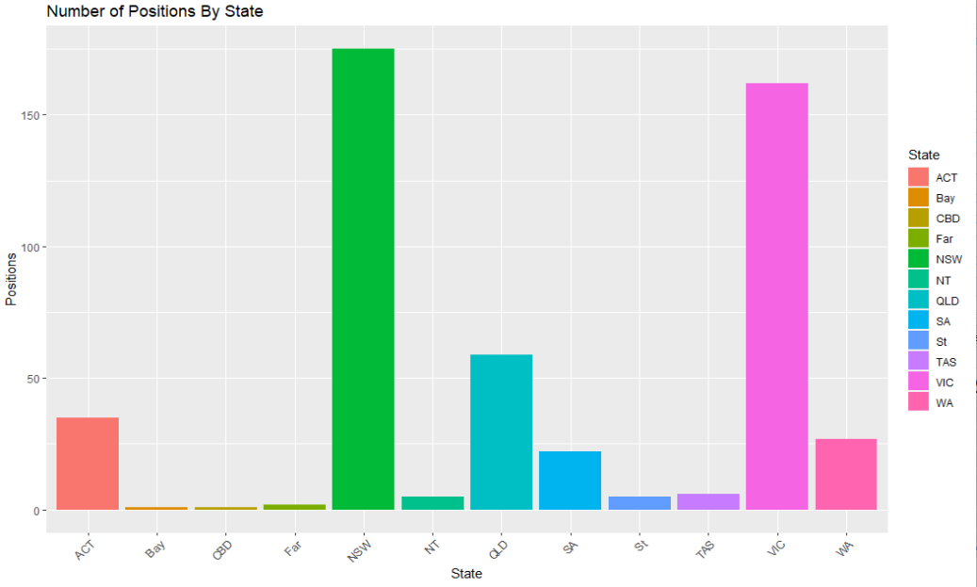

Figure : Job postings by state

The overall distribution of salaries is obtained using a histogram which is attached below. We can see that there are a very few jobs with low salaries. Most of the salaries are in mid-range.

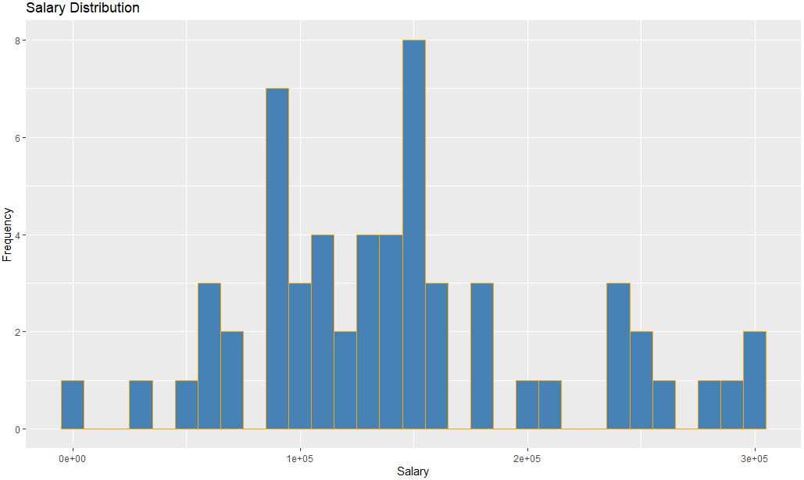

Figure : Overall distribution of salaries

When we looked at the data on salaries by state, we saw that the average pay levels varied. The average pay in the Australian Capital Territory (ACT) was $125,453, with a low of $89,680 and a high of $160,000. The fixed pay for Bay, CBD, and Far was $151,000. The average salary in NSW was $153,438. The salaries ranged from $50,000 to $277,200. Other states with different salary levels were QLD, SA, TAS, VIC, and WA. These results shed light on the link between states and salary levels and show that pay might be different in different parts of the country.

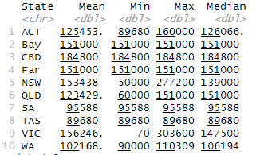

Figure : Salary statistics by state

The average salary by state is highlighted using a graph which is attached below. It is the same information presented in above table but only the mean is plotted. The top 3 states based on the highest average salaries are CBD, VIC and NSW.

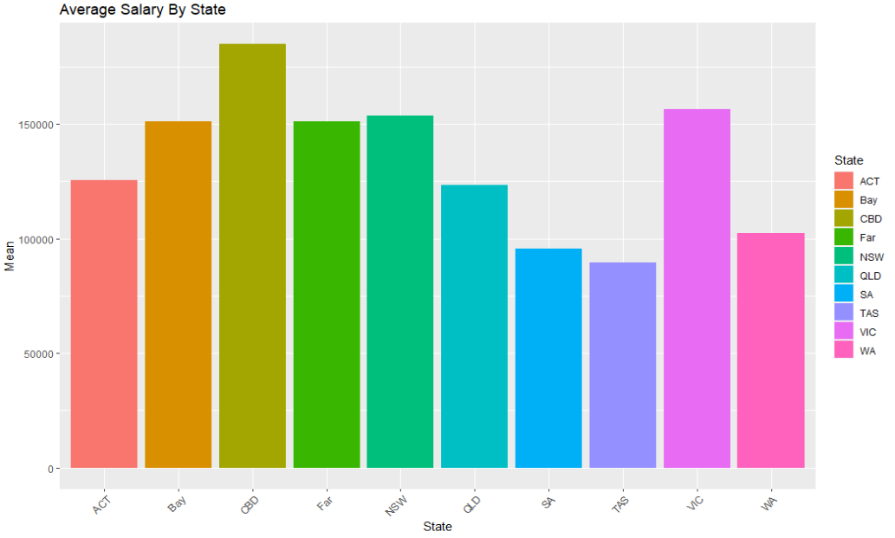

Figure : Average salary by state

Data Engineer, Senior Data Engineer, Data Analyst, Web Data and Analytics Lead – EL 1, and Azure Data Engineer were the top five job titles seen in the data scientist area. These results back up our goal of studying how popular different job names are. It shows that these job names are popular in the data science job market, which tells us what skills are in demand.

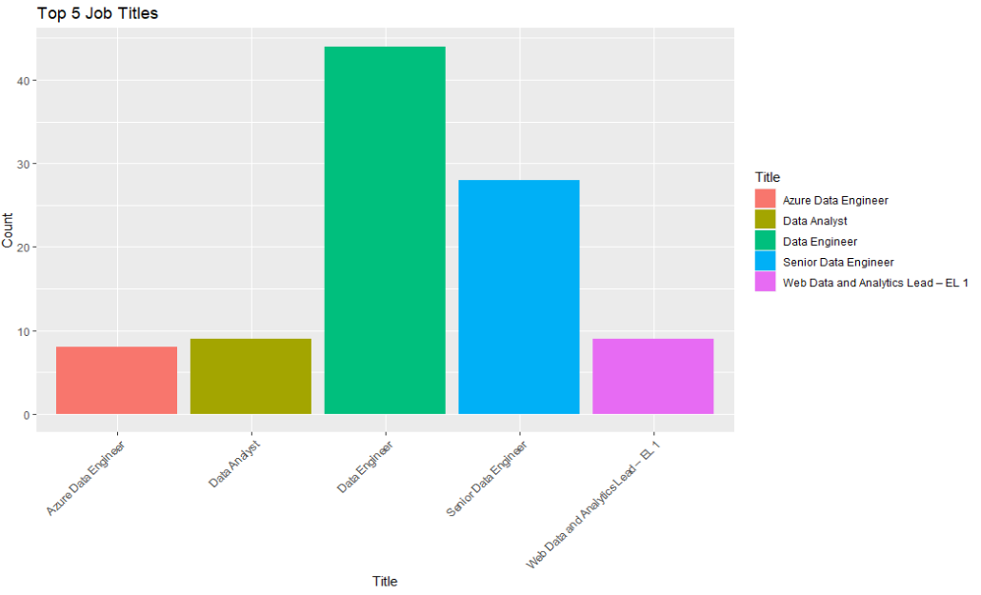

Figure : Top 5 in demand jobs

Information & Communication Technology had 310 job postings for data scientists, which was the most of any top-level industry group. With 72, 26, 20, and 19 jobs, Science & Technology, Government & Defense, Consulting & Strategy, and Education & Training were the next most important industries. Our goal was to find out how popular different businesses are when it comes to hiring data scientists.

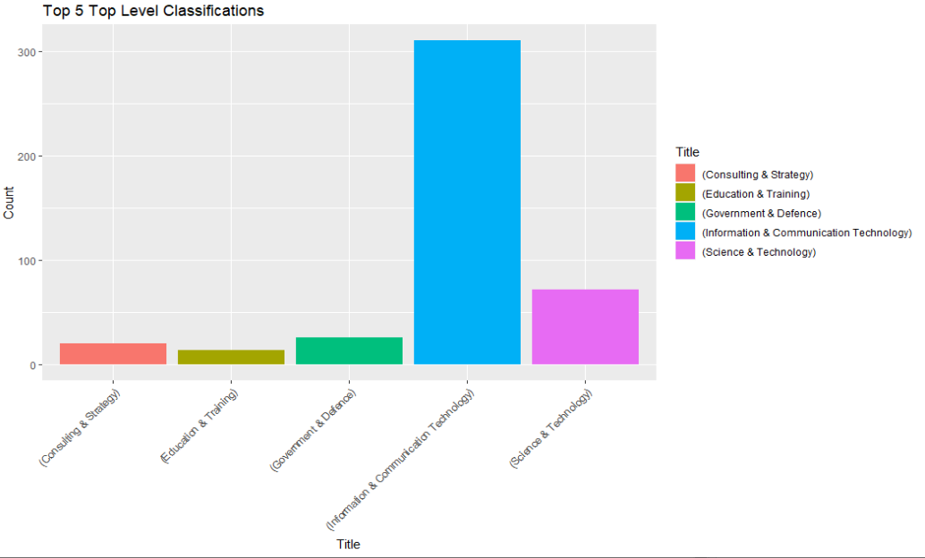

Figure : Top 5 in demand industries

By looking at average salaries by business, we can also see that Information and Communication Technology has the highest average salary at $163,128. This is followed by Banking and Financial Services, Science and Technology, and Healthcare and Medical. These insights show how industries, job opportunities, and pay levels are linked in the area of data science.

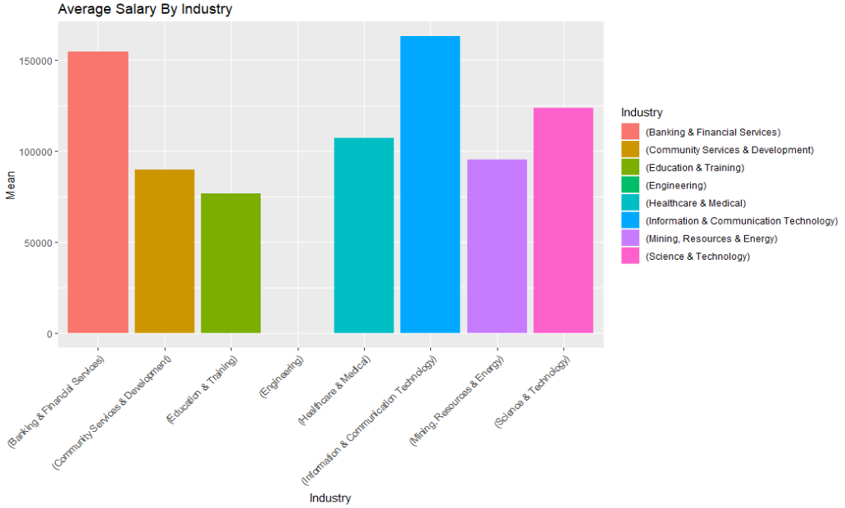

Figure : Average salaries by industry

Postings by Date and Weekday: We saw different amounts of activity when we looked at the trend of data scientist job postings over time. The number of jobs posted changed over time, with some times having more jobs posted than others. On June 24, there were a lot more job posts than any other day.

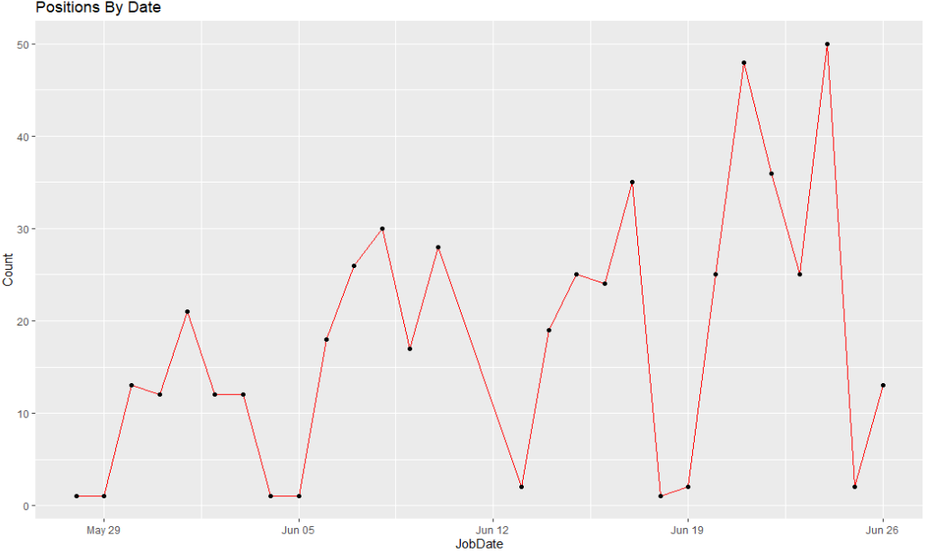

Figure : Number of job postings by date

We also looked at how many positions were posted on different days of the week and found that Thursday, Friday and Sunday had the most, with 105, 112 and 125 posts, respectively. There were a few job posts on Monday, Tuesday, and Saturday. The fewest were on Monday. These results show how job postings change over time and how weekends affect the number of data scientist jobs that are available. Overall there is a positive trend that as the week progresses, the number of jobs being posted increases.

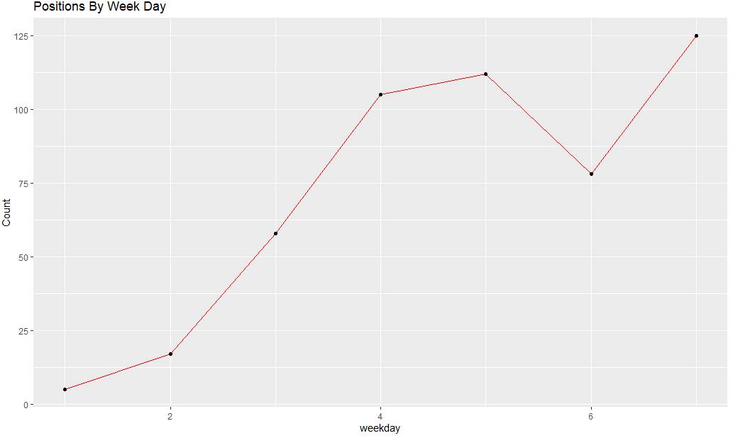

Figure : Relationship between week day and jobs posted

# Conclusion:

Our study of data scientist job postings on seek.com.au led us to a number of important conclusions. We looked at how positions were spread out across different states, how salaries varied by state and business, what the most common job titles were, and how they changed over time. When we looked at roles by state, we found that the most data scientist jobs were in New South Wales (NSW) and Victoria (VIC), which shows that there are a lot of jobs in these areas. The state-by-state salary study showed that average salaries vary, with the highest average salary level in the Australian Capital Territory (ACT). Data Engineer, Senior Data Engineer, Data Analyst, Web Data and Analytics Lead – EL 1, and Azure Data Engineer were some of the best work titles for data scientists. Employers in the area of data science want people with the skills that these titles describe. When the top-level categories of industries were looked at, Information and Communication Technology stood out as the field with the most job postings. Science & Technology, Government & Defense, Consulting & Strategy, and Education & Training all came after that. Also, the study of average salaries by industry showed that the highest average salary level was in Information and Communication Technology. The study of job postings over time showed that the number of postings changed over time, with some times having more postings than others. The link between the day of the week and the number of roles showed that the most jobs were posted on Thursday, Friday, and Sunday. Overall, our results tell us a lot about the job market for data scientists in Australia. The data show how positions are spread out, how salaries vary, what the most common job titles are, which industries people prefer, and how job postings change over time. Job seekers can use these results to learn about the job market, companies can use them to make smart hiring decisions, and policymakers can use them to learn about the data science industry.